BLACKROTH MICROSERVICES PROJECT
EPIC 07 – TASK 03
Idempotent APIs & Duplicate Request Handling
Final Technical Documentation
Document Item | Details
Project | BlackRoth Microservices
Epic | EPIC 07 – API Gateway, Resilience & Request Policies
Task | Task 03 – Idempotent APIs & Duplicate Request Handling
Execution / completion date | 06 October 2026
Author | Abhishek Gande
Primary service | Order Service
API Gateway | localhost:8080
Order Service | localhost:8082
Redis | localhost:6379
Database | MySQL – order_service_db
Status | Implemented and tested

1. Executive Summary
This task implements idempotency for the Order Service so repeated submissions of the same order request do not create duplicate orders. The client supplies an Idempotency-Key header. Redis stores the processing state and final OrderResponse for 24 hours. A repeated key returns the stored response instead of creating another order.
The implementation was verified through the API Gateway using Postman, Redis CLI and MySQL Workbench. The verified key was ORD-20261006-001 and the resulting order ID was 16409.

2. Task Objective
- Prevent duplicate order creation during retries or repeated submissions.
- Require an Idempotency-Key for order creation.
- Use Redis as the fast idempotency store.
- Return the stored response for a repeated key.
- Keep idempotency records for 24 hours using TTL.
- Verify the behavior end-to-end through gateway, Redis and MySQL.

3. Technologies Used
Technology / Component | Purpose
Java | Implementation language
Spring Boot | Application framework
Spring Web | REST API layer
Spring Data JPA / Hibernate | Order persistence
MySQL | Persistent order database
Redis | Idempotency state and response storage
StringRedisTemplate | Redis operations
Jackson ObjectMapper | Serialize/deserialize OrderResponse
API Gateway | Client-facing entry point
Postman | API testing
Docker | Redis/Kafka infrastructure
Maven | Build
Git/GitHub | Source control

4. Implementation Overview
OrderService.createOrder() validates the Idempotency-Key, checks Redis, and uses SET-if-absent to claim a new request. A PROCESSING marker protects against concurrent duplicate processing. After successful order creation, the OrderResponse is serialized and stored in Redis with a 24-hour TTL.
Redis key pattern:
idempotency:order:<Idempotency-Key>
Example:
idempotency:order:ORD-20261006-001
IDEMPOTENCY_TTL = Duration.ofHours(24);

5. Architecture
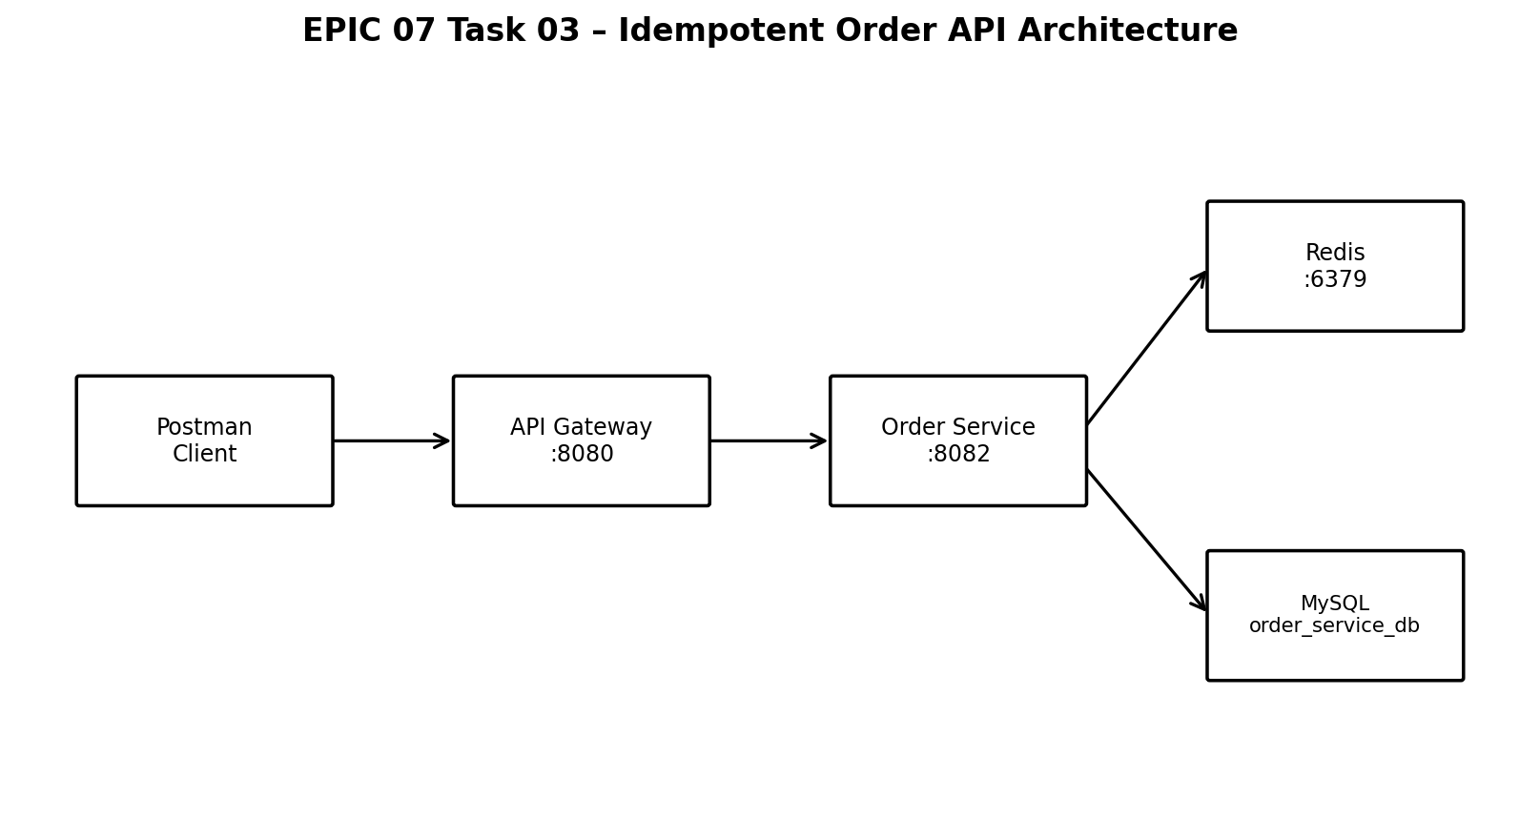
Figure 1. Idempotent Order API architecture.

6. Idempotency Workflow
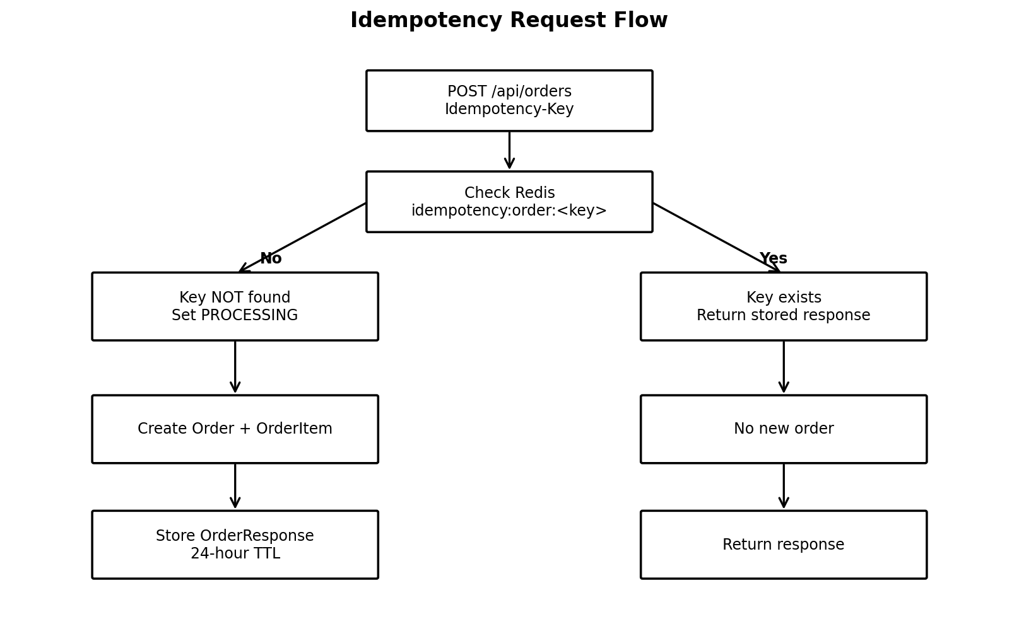
Figure 2. First-request versus repeated-request flow.

7. Detailed Workflow
Step | Action | Expected behavior
1 | Client sends POST /api/orders with Idempotency-Key | Request enters API Gateway :8080.
2 | Gateway forwards to Order Service :8082 | Order Service handles creation.
3 | Validate Idempotency-Key | Missing/blank key is rejected.
4 | Check Redis | Existing response is returned; PROCESSING indicates active work.
5 | New key: SET-if-absent PROCESSING | Concurrent duplicates are prevented.
6 | Validate user and create Order + OrderItem | Normal persistence flow runs.
7 | Publish OrderCreatedEvent | Existing event flow continues.
8 | Store OrderResponse in Redis | Stored for 24 hours.
9 | Return response | First request returns HTTP 201 Created.
10 | Repeat same key | Stored response is returned; no second order is created.

8. Step-by-Step Execution Guide
Follow these steps to reproduce the verified result.

Step 1 – Start Redis
docker ps
docker exec -it redis redis-cli
PING
PONG
Confirm Redis is running on port 6379.

Step 2 – Start supporting services
Start the services required by the existing Order Service flow, including the user service and Kafka infrastructure.

Step 3 – Start Order Service
Start Order Service and confirm it runs on port 8082. The captured startup logs showed Tomcat started on port 8082 and Kafka consumers joined their configured groups.
server:
port: 8082

Step 4 – First POST through API Gateway
POST http://localhost:8080/api/orders
Idempotency-Key: ORD-20261006-001
Content-Type: application/json
{
"userId": 1,
"productId": 1,
"productName": "Test Product",
"quantity": 1,
"amount": 100
}
Expected: HTTP 201 Created.
Field | Verified value
id | 16409
userId | 1
productName | Test Product
quantity | 1
amount | 100.0
status at creation | CREATED
createdAt | 2026-10-06T15:00:58.575538800

Step 5 – Verify Redis
docker exec -it redis redis-cli
GET idempotency:order:ORD-20261006-001
The captured Redis output contained the stored response for order 16409.

Step 6 – Verify TTL
TTL idempotency:order:ORD-20261006-001
The captured verification returned 85785 seconds remaining, confirming an active expiry.

Step 7 – Send the exact same request again
Use the same URL, body and exactly the same Idempotency-Key. The repeated request returned the existing order response rather than creating another order.

Step 8 – Verify by order ID
GET http://localhost:8080/api/orders/16409
Expected and observed: HTTP 200 OK. The response showed order 16409, user 1, Test Product, quantity 1 and amount 100.

Step 9 – Verify MySQL
USE order_service_db;
SELECT id, user_id, product_name, quantity, amount, status
FROM orders
WHERE id = 16409;
id | user_id | product_name | quantity | amount | status
16409 | 1 | Test Product | 1 | 100 | CONFIRMED

Step 10 – Confirm duplicate prevention
- First request created Order ID 16409.
- The same Idempotency-Key was reused.
- Redis contained the response for Order ID 16409.
- The repeated request returned the existing order response.
- MySQL verification identified the intended order record by ID 16409.

9. Test Evidence
Test | Expected | Observed | Status
Redis connectivity | PING → PONG | PONG | PASS
First POST | 201 Created | 201 Created; ID 16409 | PASS
Redis storage | Key contains response | Response for ID 16409 | PASS
Redis TTL | Positive expiry | 85785 seconds | PASS
GET by ID | 200 OK | 200 OK for /api/orders/16409 | PASS
MySQL verification | Record exists | 16409 / user 1 / amount 100 | PASS
Repeated POST | No duplicate | Same order response / ID 16409 | PASS

10. Evidence Details
- Postman first POST returned HTTP 201 Created with Order ID 16409, userId 1 and amount 100.0.
- Postman response headers included X-Request-ID and rate-limit headers.
- Redis GET returned the JSON response stored under idempotency:order:ORD-20261006-001.
- Redis TTL returned 85785 seconds during the captured verification.
- MySQL Workbench returned one matching row for id 16409.
- GET /api/orders/16409 returned HTTP 200 OK.

11. Important Test Observation
The Redis idempotency record captured at creation contained status CREATED, while the later MySQL/GET-by-ID verification showed status CONFIRMED. This reflects the observed flow where the response cached at creation can remain in Redis while the persistent order state changes afterward. The duplicate-request requirement was nevertheless verified: the repeated key mapped back to the original order and did not create a second order.
For future refinement, if duplicate requests must always return the latest mutable order state, the cached-response strategy would need to be designed accordingly. This is a design consideration, not a failure of the duplicate-request test.

12. Benefits
Benefit | Value
Duplicate-order protection | Same key maps to the existing response instead of creating another order.
Safe retries | Network/client retries can reuse the same key.
Concurrency protection | PROCESSING + SET-if-absent prevents simultaneous duplicates.
Fast lookup | Redis avoids unnecessary database creation work for duplicates.
Automatic cleanup | 24-hour TTL removes old keys automatically.
Consistent repeated response | Same key returns the stored response.
Traceability | Key, request, order ID and database record can be correlated.

13. Code-Level Changes
Component | Change
OrderService | Added Idempotency-Key validation.
OrderService | Added Redis lookup using StringRedisTemplate.
OrderService | Added PROCESSING marker using SET-if-absent.
OrderService | Added 24-hour TTL.
OrderService | Added ObjectMapper serialization/deserialization.
OrderService | Stored final OrderResponse in Redis.
OrderController | Accepts Idempotency-Key on order creation.
application.yml | Configured Redis localhost:6379 for dev.
Testing | Verified through Gateway, Postman, Redis CLI and MySQL Workbench.

14. Configuration Used
spring:
profiles:
active: dev
data:
redis:
host: localhost
port: 6379
server:
port: 8082
This matches the configuration verified during execution.

15. Relationship to Existing Architecture
Task 03 adds an idempotency layer around the existing order-creation path. The API Gateway remains the entry point, Order Service owns order creation, MySQL remains the persistent store, and Redis adds temporary idempotency state and response storage.
Existing component | Task 03 contribution
API Gateway | Client-facing entry point used in testing.
Order Service | Owns order creation and idempotency logic.
MySQL / order_service_db | Persistent order record.
Redis | Temporary idempotency state and response.
Postman | End-to-end verification.

16. Expected Final Result
- First POST with a new key creates one order.
- First request returns HTTP 201 Created.
- Redis contains idempotency:order:<key>.
- The key has a 24-hour expiry.
- Repeating the same request with the same key does not create another order.
- The original order ID is returned again.
- MySQL contains the original order record.

17. Troubleshooting Checklist
Problem | Check
Redis connection failure | Confirm Redis container and port 6379.
Missing Idempotency-Key | Add the header to POST /api/orders.
New order appears on retry | Verify the exact same key is reused and Redis contains it.
Redis key missing | Check Redis host/port and use redis-cli GET.
Gateway failure | Confirm Gateway :8080 and Order Service :8082.
Database mismatch | Query order_service_db using the returned order ID.

18. Final Status
Item | Status
Idempotency-Key validation | Completed
Redis idempotency storage | Completed
PROCESSING protection | Completed
24-hour TTL | Completed
First-request test | Passed
Repeated-request test | Passed
Redis verification | Passed
MySQL verification | Passed
Gateway end-to-end test | Passed
Documentation | Completed

19. Conclusion
EPIC 07 Task 03 successfully adds idempotent behavior to the Order Service. Redis identifies previously processed requests, prevents duplicate processing, and returns the stored response for repeated requests. End-to-end testing through the API Gateway, together with Redis CLI and MySQL Workbench verification, confirmed the intended behavior. The tested key ORD-20261006-001 mapped to Order ID 16409 and protected the order-creation operation from duplicate submission.

